

**[ATM REPORTING SYSTEM]**

**Group Names**

**Sabrina Yafiet 21/1342/BIT-J**

**Emmanuel Wani 21/1143/BIT-J**

**Betelihem Tesfalem 21 *1780*/BSCS-J**

**Ayko**

**FACULTY OF SCIENCE AND TECHNOLOGY**

A project report submitted to the faculty of science and technology in partial fulfillment of the requirements for the Award of the Degree of Bachelor Science in Computer Science, of international university of East Africa.

**Supervisor:**

**Month, 2022**

**1: Project Description**

**2: Define the problem**

**3: Present your solution**

**4: Define your deliverables and success criteria**

**5: State your plan or approach**

**6: Outline your project schedule and budget**

**7: Tie it all together**

**8: Edit/proofread your proposal**

**Description:**

Generally, banking system has been working continuously for many years. Cash or paper money has been the payment mechanism for centuries in nationwide. In traditional banking methods customer will need to interact with the cashier which will be appointed by the bank to handle bank services such as withdraw money cash deposits and reporting loss of ATM cards by customers. At times when a customer should be performing any services on the bank, the process are done over the counter. In modern days, the system banking has changed in a technological way where Automated Teller Machine (ATM) was introduced. The ATM provides many functions as required, but the current method has shown few drawbacks until he loses his ATM debit card. From this point of view customers will need to perform the report through traditional methods which are manually reporting it to the bank which could delay the time taken to perform and reporting it through hotlines where it might face unexpected and scheduled maintenance. To address the current drawbacks as stated, ATM reporting system has been proposed as an alternative method where it only requires customers to report the loss through the ATM machine which in fact could provide the ease of usage to the customers

1. **Introduction**

The main purpose of this proposed idea is mainly focusing on the new feature that can be implemented as a possible alternative to the traditional methods. Automated Teller Machine (ATM) has been working for a long term, providing all the required features for the customers to use such as withdrawing money or cash deposits. Based on the traditional methods in banking system, the bank will appoint a person, the teller to assist the customers when the customers need to perform any services in a bank. The customers on the other hand, will need to request for forms and the forms will be submitted to the counter. In order to perform, customers will need to queue up the line while waiting for their turns. ATM refers to a machine that acts as a bank teller by receiving and issuing money to and from the ATM account holders/users. In this new era of technology, ATM machine was used as a convenient way of getting his money from banks. These customers would not have to queue for longer lines while waiting for their turns but instead, these customers only need their ATM cards to perform such services. A person will no longer have to carry a wallet-full of paper money, or in the other terms, cash along to where the customers want to go. Customers will only need the ATM card, insert it in the slot of the machine without having any required form to perform their wanted services.

ATM is designed to perform the most important functions of the bank. By using plastic cards, containing all personal details of the customers and they will only need to enter their pin numbers in order to use the services. ATM is an Electronic Fund Transfer that is capable of handling many functions, until when a person loss his ATM cards. Instead of using the traditional methods which are queuing up the line and by hotline phone call, this could be the possible alternative adding

the new feature on the ATM machine, where it could be less time consuming.

**Problem Statement:**

Money has formed different shapes in the recent years and it was reshaped from paper money to plastic money in terms of debit and credit cards and now has become digital money due to the digitization process.

The revolution of digital development has affected almost every aspect of life. Things that were done manually have now been done by computer. In fact computerization of almost everything has been started some times back. Computer is suggesting not only life savings drugs it also helping to discover new planet and galaxies.

In all of these facts why many of the Banks are still recording money transactions manually and storing the record on papers the results in cutting more and more trees to produce papers.

The ATM reporting system is very important to overcome the hot line and the lack of customer’s knowledge on reporting a lost card through ATM, as their customer service would not be available. The problem statements are:

* Lack of knowledge in hotlines services might be a problem in reporting the loss of ATM card.
* The traditional methods might face unexpected and

scheduled maintenance which could delay the time taken for the customers to report loss of ATM card.

* Report the loss of card manually could not notify the user if actions have already taken.

**The objectives of the project are:**

* To develop a system with ease of usage where customers can report the loss of ATM debit cards through the ATM machine.
* To improvise the current method as an alternative in

reporting the loss by only using the ATM machine.

* To be able to notify users when actions have already taken.

**Solution:**

**ATM Reporting System** will be the premier software to be chosen by Banks to receive money from around the world or country in just a few minutes and it will be a package of software applications for everyone that combine grace, simplicity and ease of use with the powerful and robust feature set most requested by experts.

Following are the few outlines of the solutions that ATM reporting system is intended to provide.

* It will be easy to configure and personalize with complete control.
* It will offer a variety of different form of transaction. (i.e User name, Password, Account Balance, Account information, Withdrawal etc. )

**Scope:**

There are different system s that serve different purposes thus it is necessary to define the scope of ATM reporting system to make it better to understand the specific goals and usage of this system regarding user perspective.

* Account holder can take money everywhere from country through ATM.
* Customer can do transaction every time.
* Customer can check his/her Balance of Account provided he/she it’s the owner.
* Average withdrawal amount
* Security module
* ATM availability

**Features:**

ATM reporting system is armed to provide following features at it’s initial stage and many more in future versions.

* Cash Withdrawal
* Account Status
* Fast cash
* Not required specific bank timing
* Not required specific location
* Facilitate other bank’s customers

II.  **METHODOLOGY**

In this section describes the approach and the methodology that is used to develop ATM reporting system. The research started off by having literature survey to understand better on the ATM machine whether it is an empirical or in theoretical way. Studies are made to analyse the importance of having the ATM machine and how it can benefit to the customer. After having the literature survey done, a review was also made that includes the review of the current situation and review of the related literature.

2.1 **Project Methodology**

The methodology used for the ATM reporting system is the agile methodology. Agile methodology is a type of project management process where it anticipates change and allows for much more flexibility than the traditional methods. In this

methodology, it consist of 6 phases which are planning, designing, developing, testing, release and feedback. Agility in short means to reduce as much of the heaviness commonly associated with the traditional software development

methodologies in order to promote quick response to change the environment.

2.1.1 **Coding**

In this project, the language that will be used to develop the system is Java Programming language because it is much easier to make a design interface using Java. Other than that, CSS and HTML languages are used in order to make the design of the interface more interactive. Java Programming benefits users to

collaborate with the external languages to be in one file. Java is a general-purpose of computer-programming language that is concurrent, class-based, and object-oriented. It specifically was designed to have a few implementation dependencies as possible.

2.1.2 **SQLite**

For the project, database plays an important role to save the data of the customers who are using the product. SQLite has been chosen for the database of the project. SQLite is an in process library that implements a self-contained, server less, zero

configuration and transactional SQL database engine. The code for the SQLite is in the public domain and is free for user to use for any purpose whether it is commercial or private. SQLite is the most widely deployed database in the world with more applications than we can count, including several high-profile projects.

2.2 **Development Methodology**

In this section, the development methodology for the ATM reporting system is Agile Unified Process . It is one of the simplest and easy methods to understand the approach in developing the application. This method consist of four phases which are the inception, elaboration, construction and transition. Figure 1. illustrates the process.

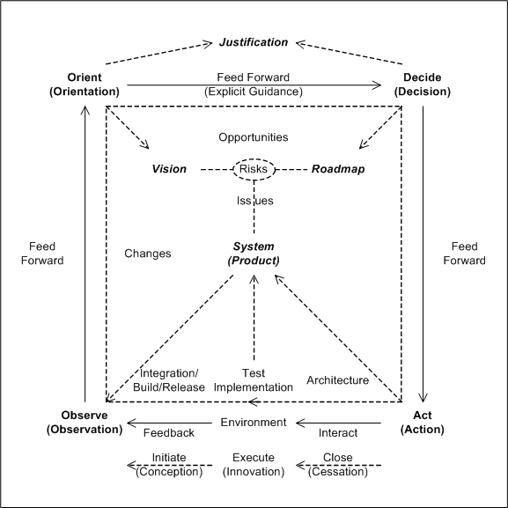

In the inception phase, model workflow is considered as the initial step in the Agile Unified Process. Systems designs are included in this phase to see the flow of the project including the system design’s diagrams.

2.2.1 **Use case diagram**

The use case diagram of the ATM reporting system is to show the interaction between customers and the bankers. In this case, customers can use all ATM services including performing the report on loss of ATM card.

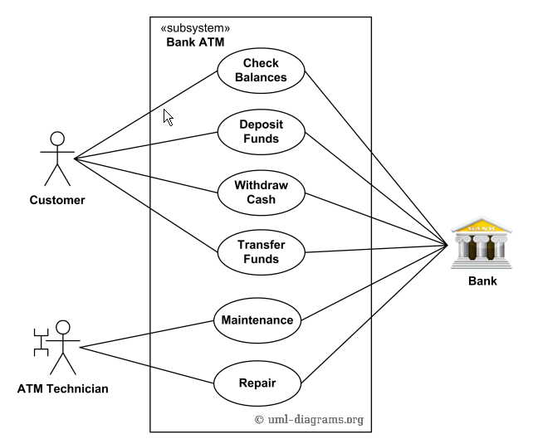

2.2.2 **Sequence Diagram**

The sequence diagram below shows the interaction between customers, the ATM and the bank.

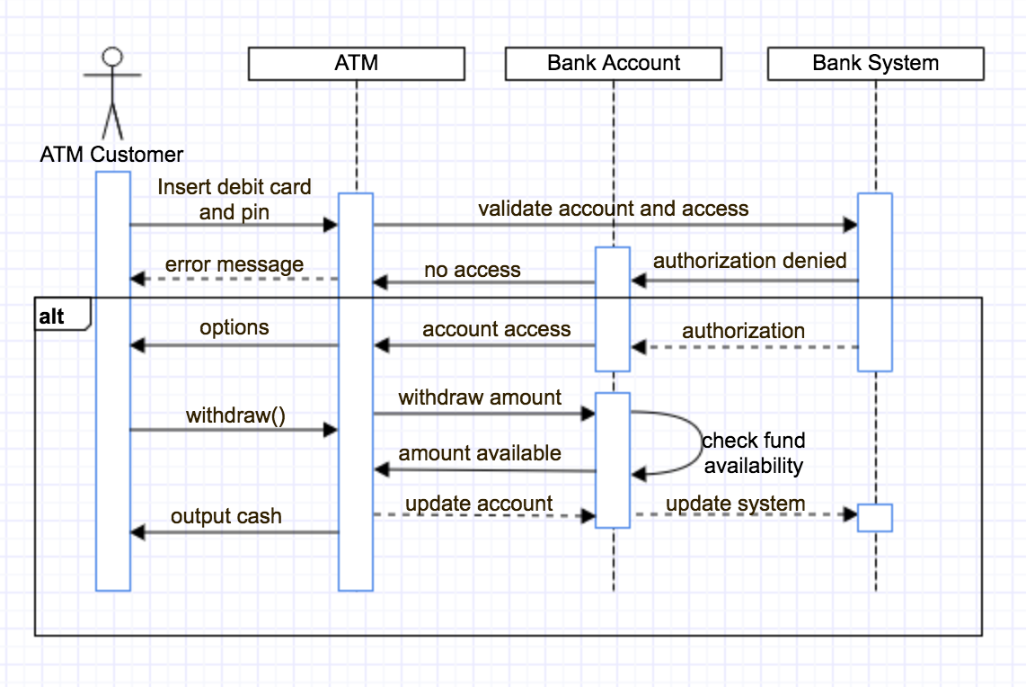

2.2.3 **State Machine Diagram**

In this section, the state machine diagram shows the user interaction in the system on what the user can do and providing the step while the system is running. The illustration is shown

below.

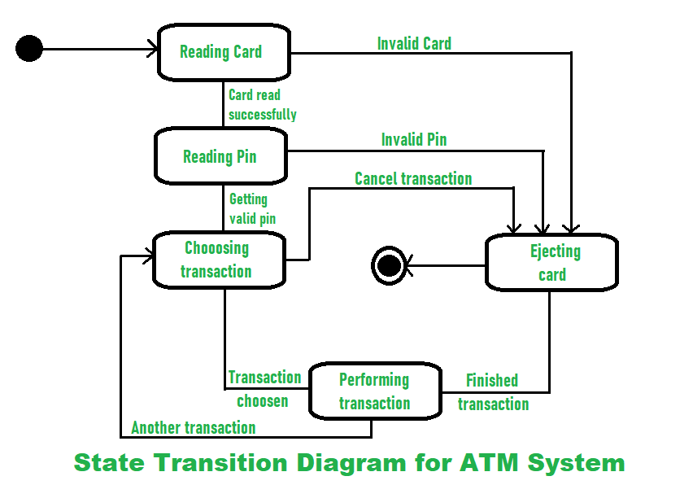

**FINDINGS AND DISCUSSION**

In this section, it covers all to conclude the research, planning, methods uses and tester about the project in order for better understanding. This section will also cover project object analysis, unit testing, system testing, user acceptance testing, and analysis.

3.1 **Project object analysis**

The main objective of this project will be analysed on whether the complete system will solve the proposed objectives, whether the problem can be solve as mentioned in problem statement the earlier chapter. The first objective is to develop a system that can provide the ease of usage where customers can

report the loss of ATM debit cards through the ATM machine itself, the second objective is to modernize the current method as an alternative in reporting the loss and the last objective is to be able to notify the user if actions have been taken.

3.2 **Unit testing**

Unit testing is a level of software testing where individual function/method of a software are tested. The main aim of unit testing is to validate that each function of the software performs as designed. For this phase, it is easier to identify whether some of the coding or system do not work.

3.3 **System testing**

A prototype has been made for the ATM reporting system and the system consist of the proposed feature where “Block ATM card” is implemented. The function of the implementation is to enable user to perform reporting loss of ATM card only through the ATM Reporting Machine.

Figure 5 below shows the main display of the ATM reporting system, where it shows all the list of services provided in the system including the new feature which is block ATM card.

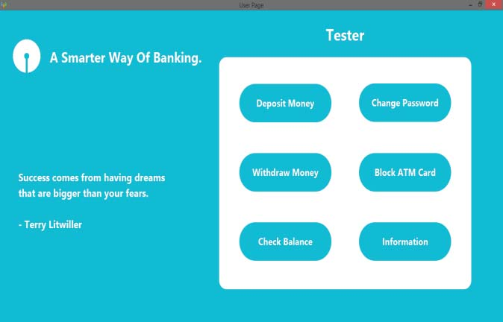

In the figure 6 below it shows the block ATM card page, where the new feature is implemented into the ATM machine. Through this method, customers will be able to perform a report only by using the machine. User will only need to enter his IC number and his PIN number into the system.

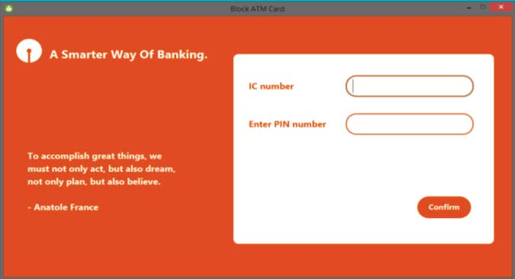

Several test has been made and as for the results, it is shown in the table below:

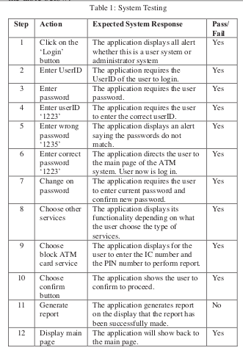

3.4 **Analysis**

In this section, the answer provided by the participants is the main attention to see how the participants respond to the ATM reporting system. A survey is conducted and some questions are delivered to the people regarding system. By analysing the question distributed, accurate objectives can be obtained and the results for the questions are illustrated as the following figures.

In the figure below, illustrates the seventh question whether the implementation of the new features can be easier to perform loss of ATM card through the ATM machine itself. The main objective of this question was to determine whether the new feature could benefit to the people who owns the ATM debit card. From the figure below, it has shown that many have given their positive feedback on this implementation nearly 80% of

the respondents answered yes. Only one person who answered no, and 20% of them answered maybe.

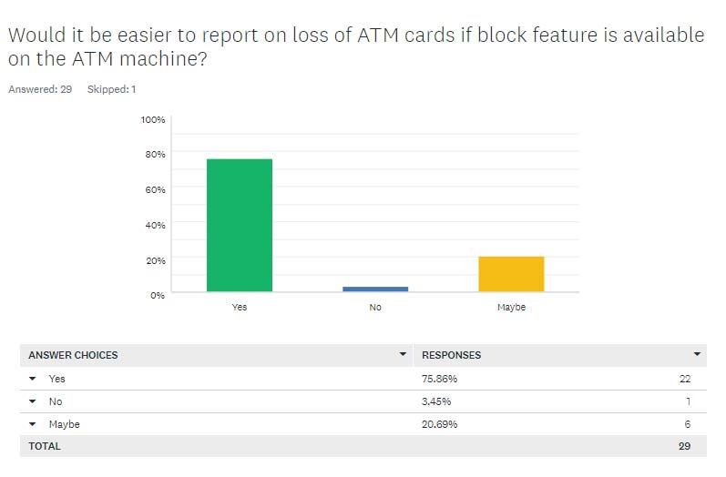

In the figure 9 below, showed the ninth question that is included in the survey. The question was asked to see whether respondents agree that by adding this feature on the ATM machine can provide the ease of usage to the customers. The main objective of this question is to see the rate of the respondents who agreed that the system can provide the ease of usage in the future. Reflecting to the objectives of this project, it is to provide a system with ease of usage of reporting the loss of ATM cards. The objective was concerning to those customers who have difficulties to report the loss since traditional methods such as queuing up the line and hotlines draws some drawbacks. Based on the result below, 90% of the respondents agreed while the rest of 10% did not agree.

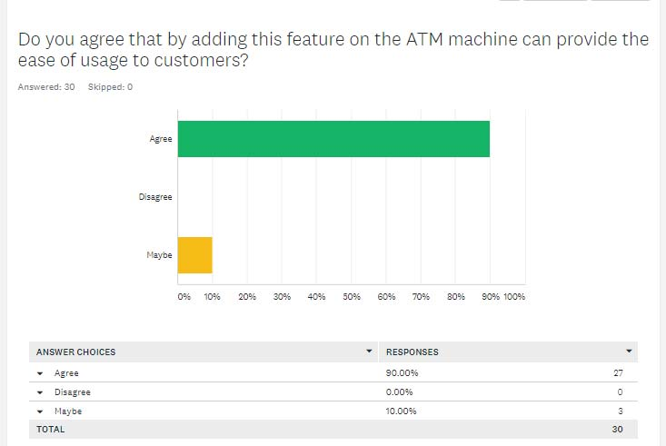

**CONCLUSION**

In this project, the objective concerned only to improvise a method where customer can perform an ATM loss card report through the ATM machine. The Automated Teller Machine Reporting system application is to help the user who has problems reporting the loss of ATM card. The implementation

will ensure that the system can bring benefits especially to the customers in this evolving era of technologies. This project has introduced a new prototype for ATM reporting system and make the ATM machine usable and acceptable. In this system, there are more objectives that could possibly be implemented in future work such as implementing a higher level of security

to avoid customers from being scam or fall into the phishing trap.